**8 hours exam:**

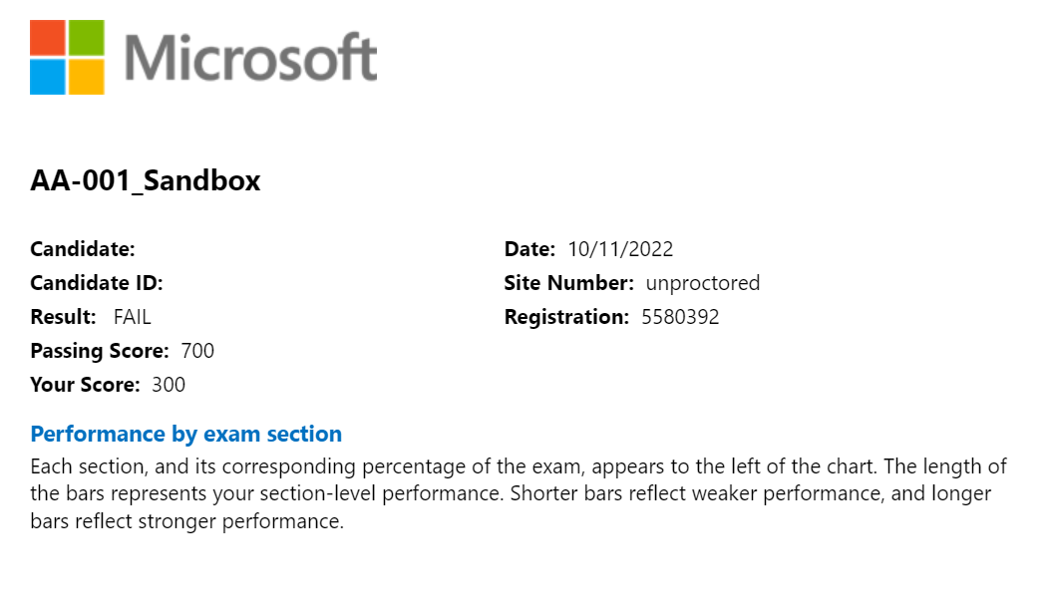

Admission Policy

We ask that you arrive at the test center 15 minutes before your scheduled appointment time. This will give you adequate time to complete the necessary sign-in procedures. If you arrive more than 15 minutes late for your appointment, you may be refused admission and the exam fees will be forfeited.

You will be required to present one form of original (no photocopies), valid (unexpired) government issued ID that includes your name, photograph, and signature. The first and last name that you used to register must match exactly the first and last name on the ID that is presented on test day. All IDs required must be issued by the country in which you are testing. If you do not have the qualifying ID issued from the country you are testing in, an International Travel Passport from your country of citizenship is required. If you have any questions or concerns about the ID you are required to bring with you to the testing center for admittance for your exam please contact Pearson VUE customer service at https://home.pearsonvue.com/Test-takers/Customer-service.aspx. To view the full ID policy, including any additional allowances to this policy, please visit http://www.pearsonvue.com/policies/1.pdf.

This exam admission process also includes the following Enhanced Security Protocol admission steps:  
  
• Digital Signature  
• Digital Photograph  
  
You will not be allowed to take any personal items with you into the testing room. This includes all bags or purses, books, notes, personal computers or devices, cell phones, pagers, watches and wallets.

Reschedule Policy

If you need to reschedule your appointment, be sure to do it no later than 24 hours prior to your scheduled exam. If you do not reschedule your appointment 24 hours prior to your scheduled exam, you will forfeit your exam fee and/or your company may incur a charge.

Cancellation Policy

If you need to cancel your appointment, be sure to do it no later than 24 hours prior to your scheduled exam. If you do not cancel your appointment 24 hours prior to your scheduled exam, you will forfeit your exam fee and/or your company may incur a charge.

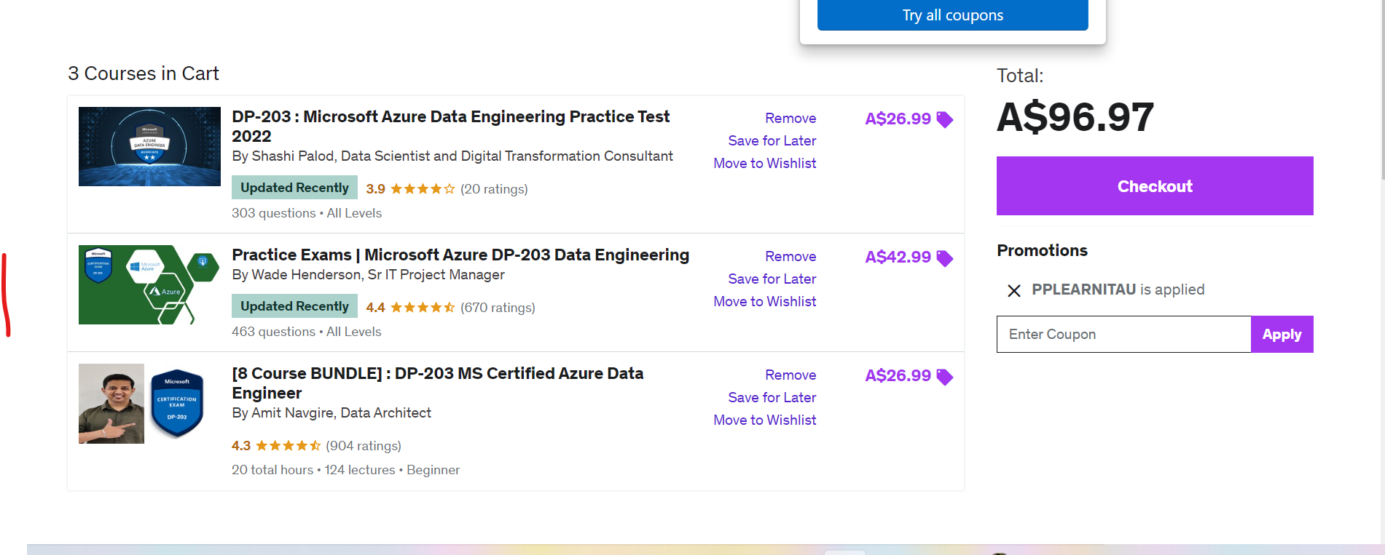

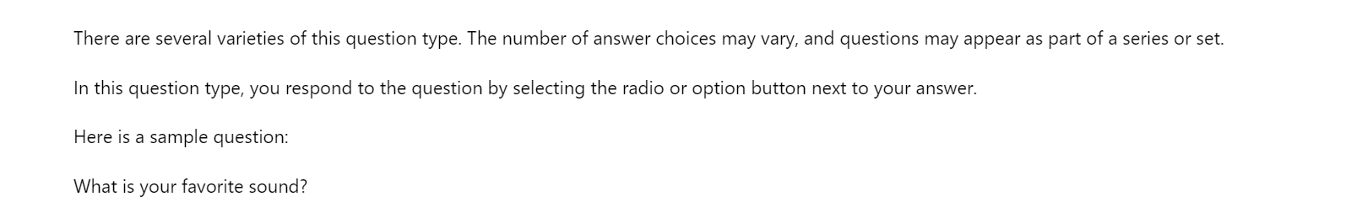

Single answer, multiple answer questions,

Drag and drop questions to answer right to left as below

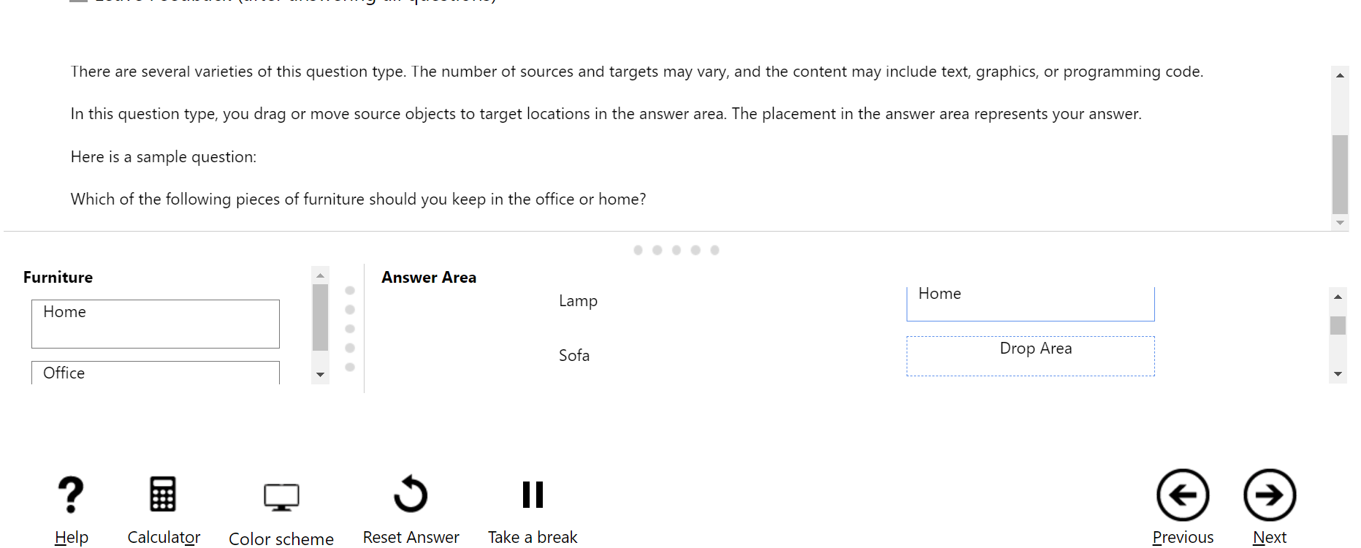

RE ORDER PARAGRAH:

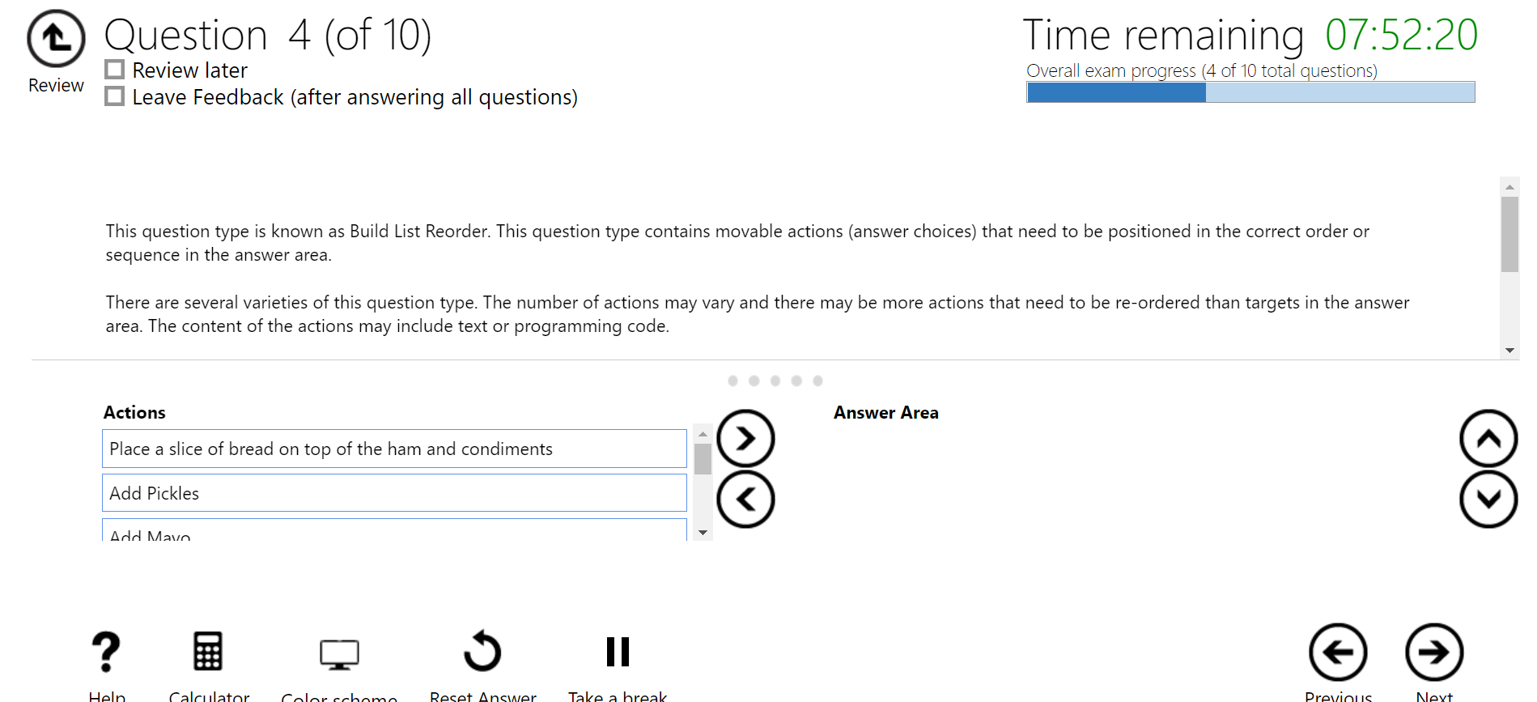

Question 5 is a

This question type is called Active Screen. This question type contains interactive screen elements, such as dropdown menus, option buttons, or spin boxes.

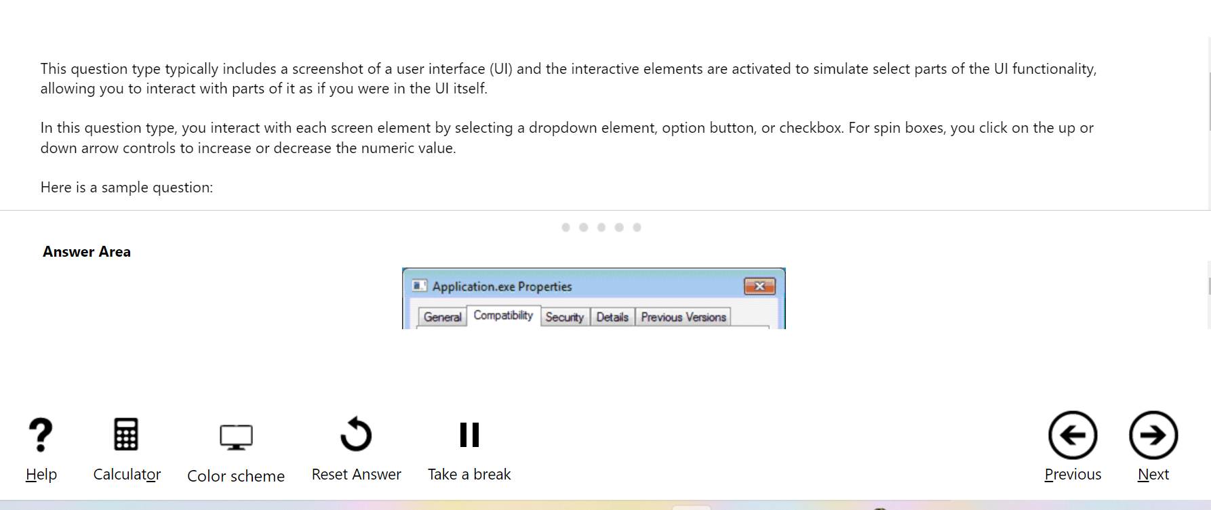

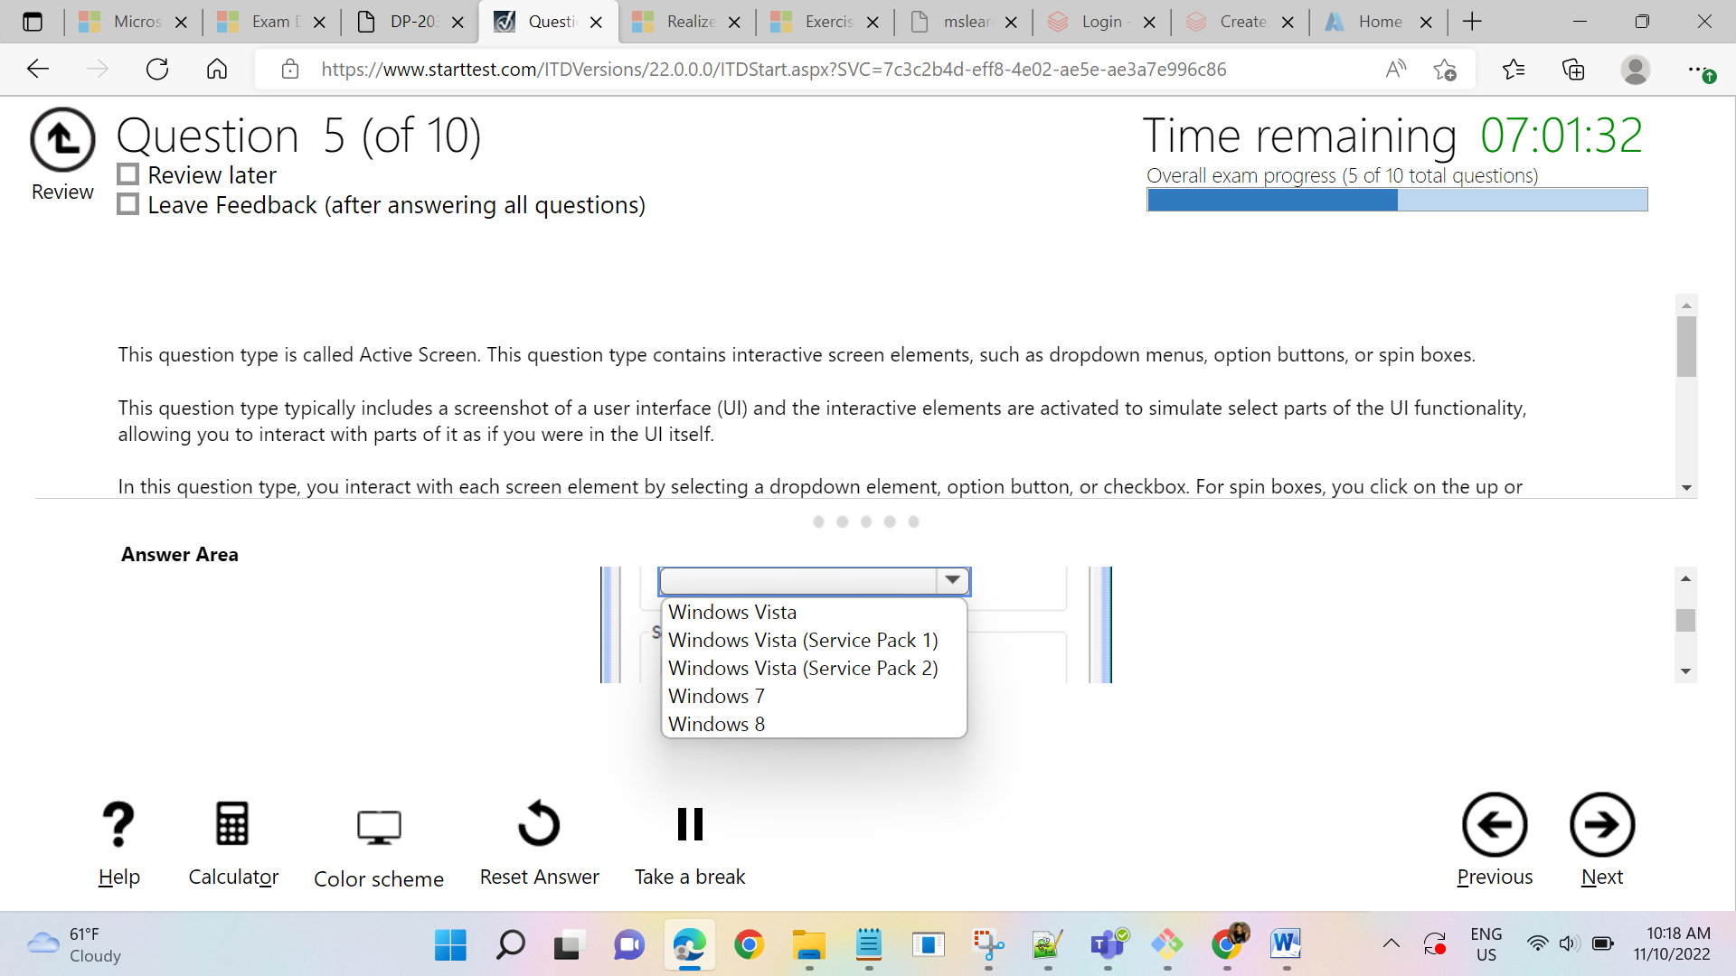

Question 6 :

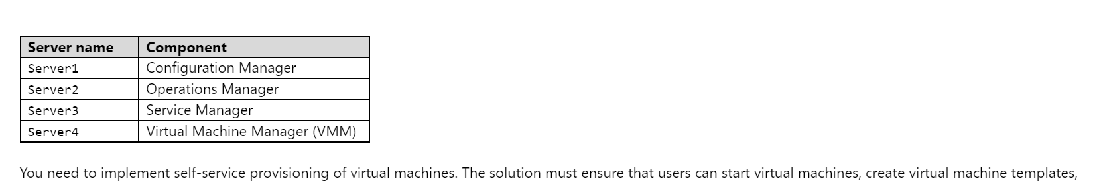

Instead of screenshot in the question 5, we may require that you complete a statement or make choices using the interactive elements.

like dropdown, option button or checkbox. For Spin boxes, you click on the up or down arrow controls

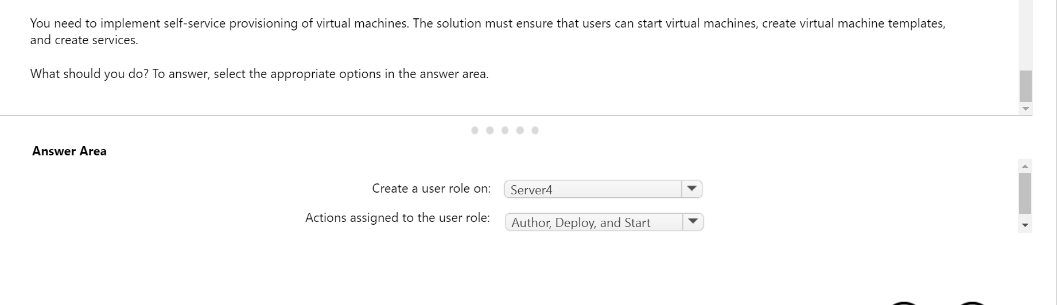

Question 7:

Like this below

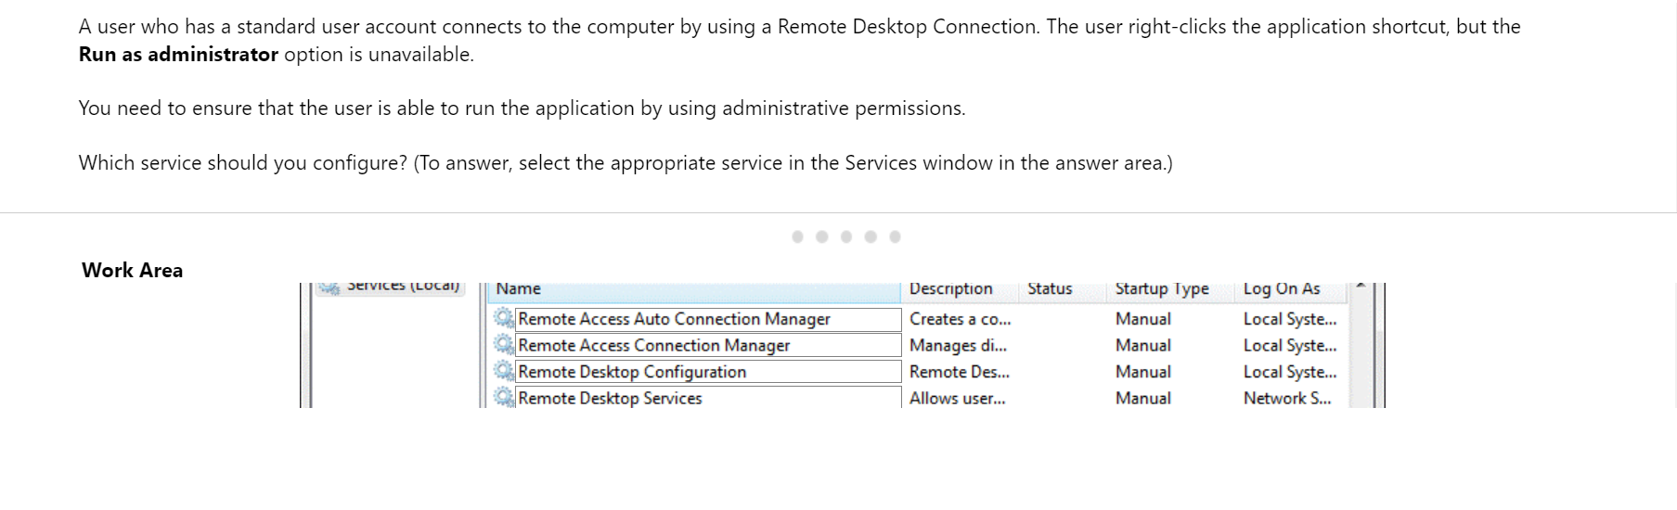

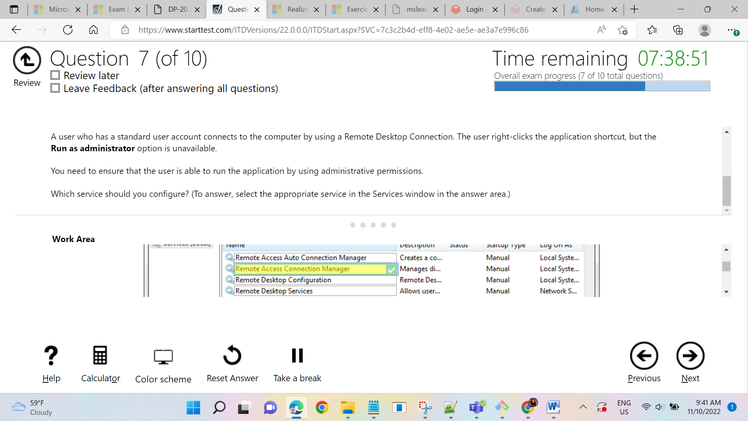

QUESTION 8

In question 8, you will be given a case study with existing environment and requirements as given in the below screenshot.

We need to complete the case study accordingly by giving an radio button or multiple choice answer.

